# **How to generate Newman Report in Jenkins**

***Last Updated On***

[**HOME**](https://qaautomation.expert/)

Postman contains a full-featured testing sandbox that enables you to write and execute JavaScript-based tests for your API. You can then integrate Postman with your ***CI/CD build system using***[***Newman***](https://learning.postman.com/docs/collections/using-newman-cli/command-line-integration-with-newman/), the command-line collection runner for Postman. In this tutorial, we are going to learn how we can ***create a Newman Report in Jenkins.***

***Table of Contents***

1. [***Prerequisite***](https://qaautomation.expert/2023/09/14/how-to-generate-newman-report-in-jenkins/#why-do-we-need-to-integrate-jmeter-with-jenkins)
2. [***Implementation Steps***](https://qaautomation.expert/2023/09/14/how-to-generate-newman-report-in-jenkins/#implementation-steps)
3. [***Download the NodeJS Plugin***](https://qaautomation.expert/2023/09/14/how-to-generate-newman-report-in-jenkins/#download-performance-plugin)
4. [***Global Tool Configuration for NodeJS***](https://qaautomation.expert/2023/09/14/how-to-generate-newman-report-in-jenkins/#step-2-global-tool-configuration-for-nodejs)
5. [***Create a new FreeStyle project***](https://qaautomation.expert/2023/09/14/how-to-generate-newman-report-in-jenkins/#step-1-create-a-new-freestyle-project)
6. [***Source Code Management***](https://qaautomation.expert/2023/09/14/how-to-generate-newman-report-in-jenkins/#step-2-source-code-management)
7. [***Build Environment***](https://qaautomation.expert/2023/09/14/how-to-generate-newman-report-in-jenkins/#step-5-build-environment)
8. [***Select Execute Windows batch command***](https://qaautomation.expert/2023/09/14/how-to-generate-newman-report-in-jenkins/#step-3-select-execute-windows-batch-command)
9. [***Select “Publish HTML reports” from “Post Build Actions”***](https://qaautomation.expert/2023/09/14/how-to-generate-newman-report-in-jenkins/#step-4-select-publish-html-reports-from-post-build-actions)
10. [***Execute the tests***](https://qaautomation.expert/2023/09/14/how-to-generate-newman-report-in-jenkins/#step-5-execute-the-tests)
11. [***View the HTML Report***](https://qaautomation.expert/2023/09/14/how-to-generate-newman-report-in-jenkins/#step-6-view-the-html-report)

### ***Prerequisite:***

* Jenkins installed on the machine
* NodeJS installed on the machine

### ***Implementation Steps***

#### ***Step 1: Download the NodeJS Plugin***

To generate a Performance Report in Jenkins, we need to download ***NodeJS Plugin***. Please refer to this tutorial to install the plugin – [***How to install Plugins in Jenkins***](https://qaautomation.expert/2022/12/12/how-to-install-plugins-in-jenkins/).

Go to **Manage Jenkins > Manage Plugins** and install the NodeJS plugin.

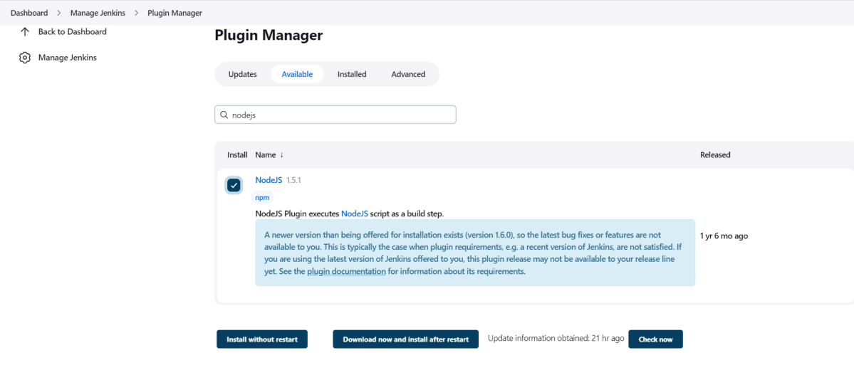

#### ***Step 2: Global Tool Configuration for NodeJS***

Go to ***Manage Jenkins > Global Tool Configuration****and under****NodeJS****, select****Add NodeJS***.

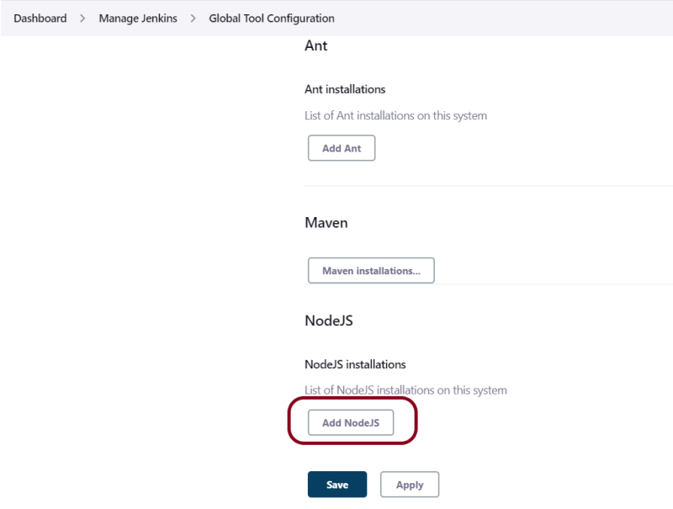

Advertisement

Enter a name for the Node.js installation.

Select the version of NodeJS installed on your machine from the Version dropbox.

In ***Global npm packages to install***, enter ***newman***.

Click on the ***Apply***and ***Save***buttons.

#### ***Step 3: Create a new FreeStyle project***

1. *Give the****Name****of the project* – ***Postman_Demo***
2. *Click on the****FreeStyle project.***
3. *Click on the****OK****button.*

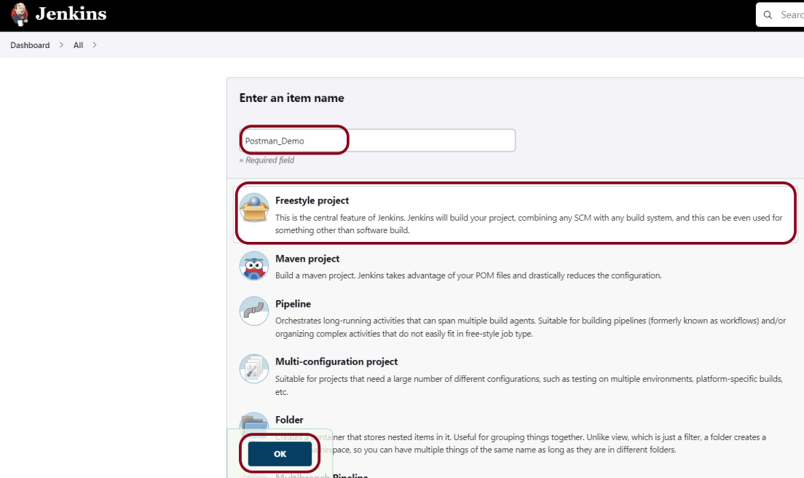

In the General section, enter the project ***description***in the Description box.

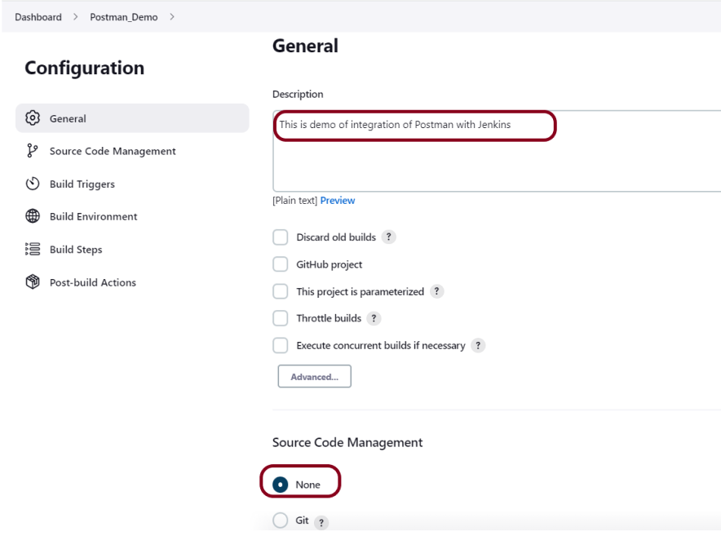

#### ***Step 4: Source Code Management***

Select ***Source Code Management as None***if the project is locally present on the machine.

#### ***Step 5: Build Environment***

Select the ***“Provide Node & npm bin/folder to PATH”*** option.

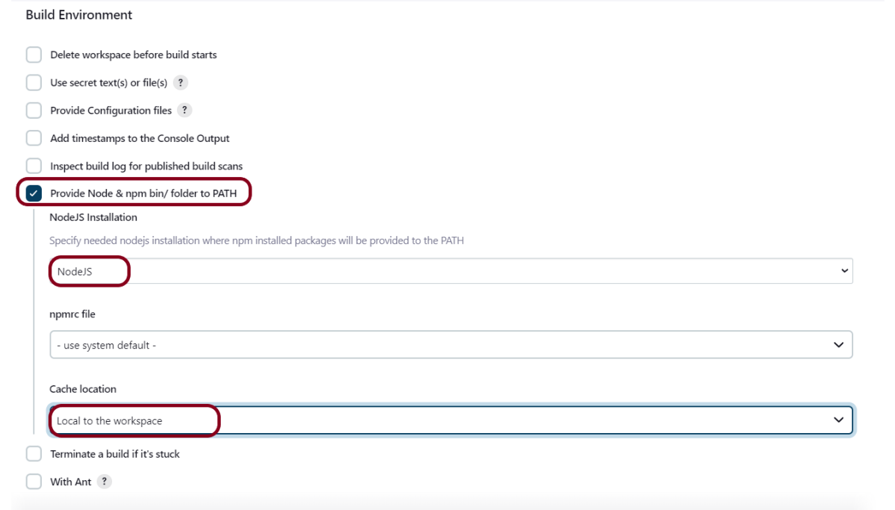

#### ***Step 6: Select Execute Windows batch command***

In the Build Steps section, select ***Execute Windows batch command***.

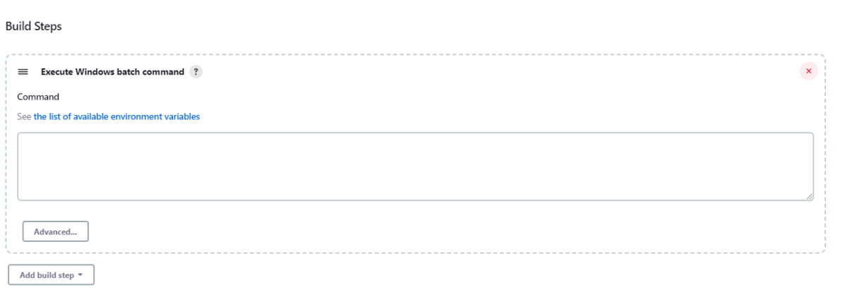

Use the below command to go to the path where the JMeter is placed in your system.

|  |  |
| --- | --- |
| 1  2 | cd C:\Users\Vibha\Desktop\Postman  newman run --disable-unicode API_Newman_PassedTests.json --reporters htmlextra --reporter-htmlextra-export ./results/report.html |

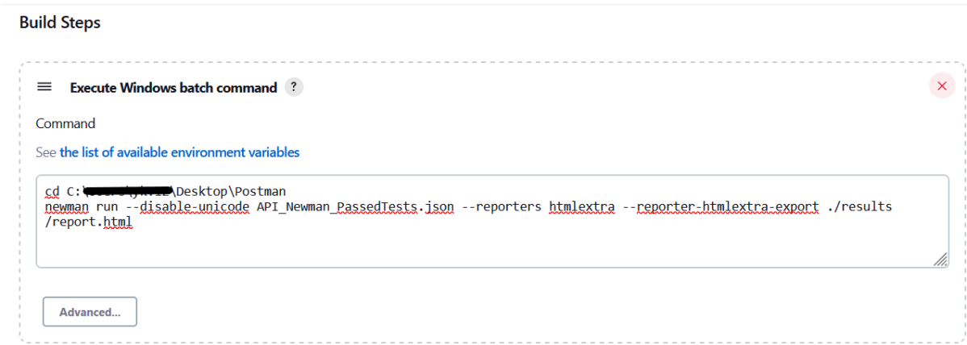

#### **Step 7: *Select “Publish HTML reports” from “Post Build Actions”***

Scroll down to ***“Post Build Actions”*** and click on the***“Add Post Build Actions”***drop-down list. Select “***Publish HTML reports***“.

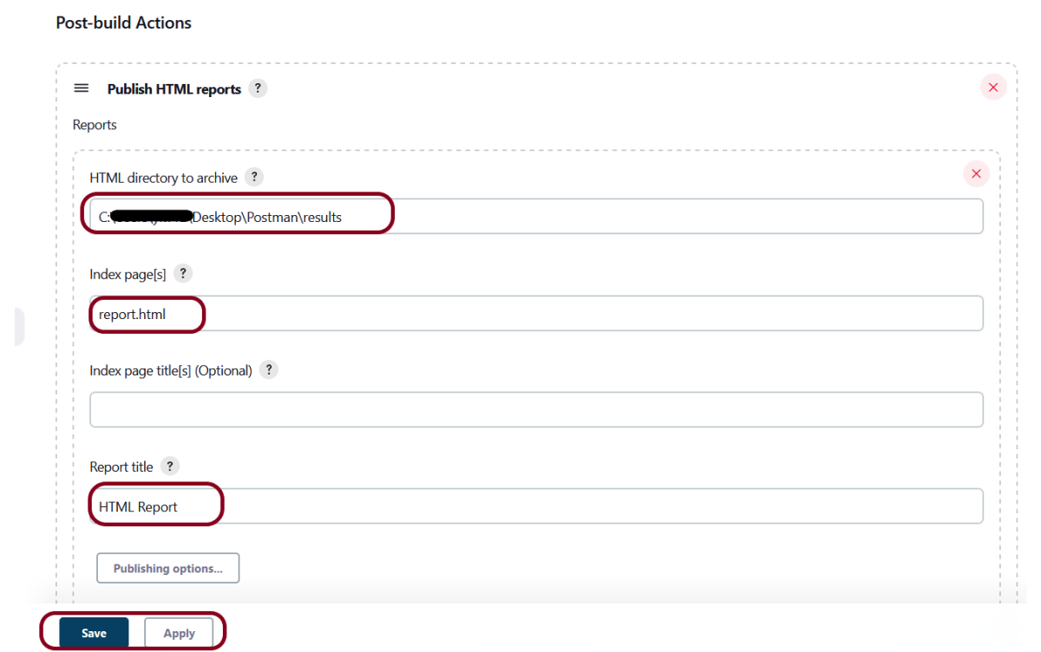

Enter the HTML directory to archive – ..\Postman\results, Index page[s] –***report.html*** and Report title – ***HTML Report***.

Click on the ***Apply***and ***Save***buttons.

If you want to see where the report is saved on desktop, go to – ***C:\ProgramData\Jenkins.jenkins\jobs\Postman_Demo\htmlreports\HTML_20Report***.

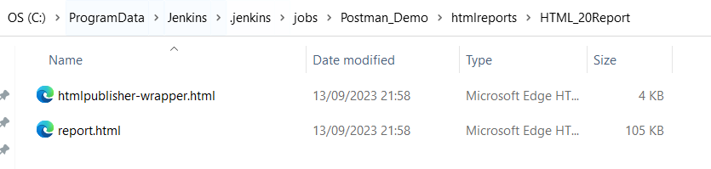

We have created a new project **“*Postman_Demo***” with the configuration to run the Postman scripts.

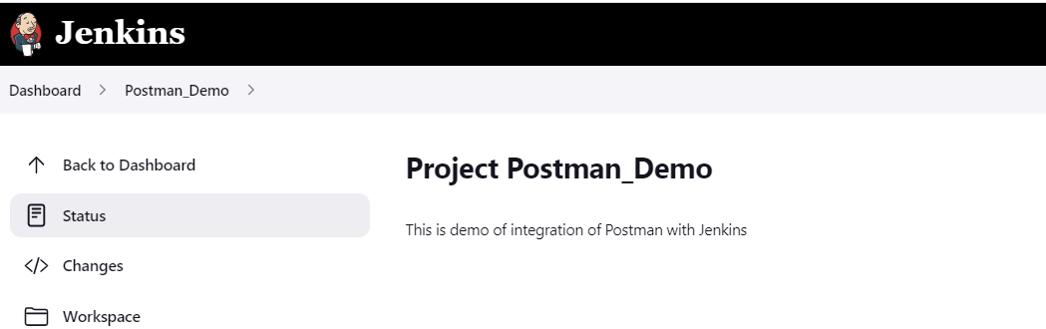

#### ***Step 8: Execute the tests***

Let’s execute it now by clicking on the “***Build Now***” button.

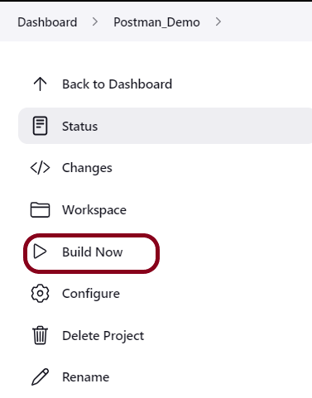

***Right-click*** on Build Number (here in my case it is #1).

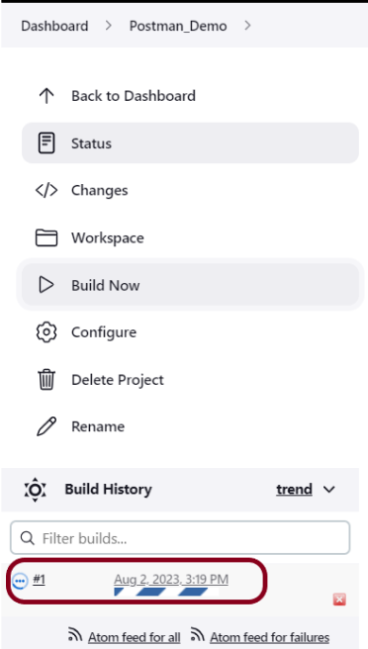

Click on ***Console Output*** to see the result.

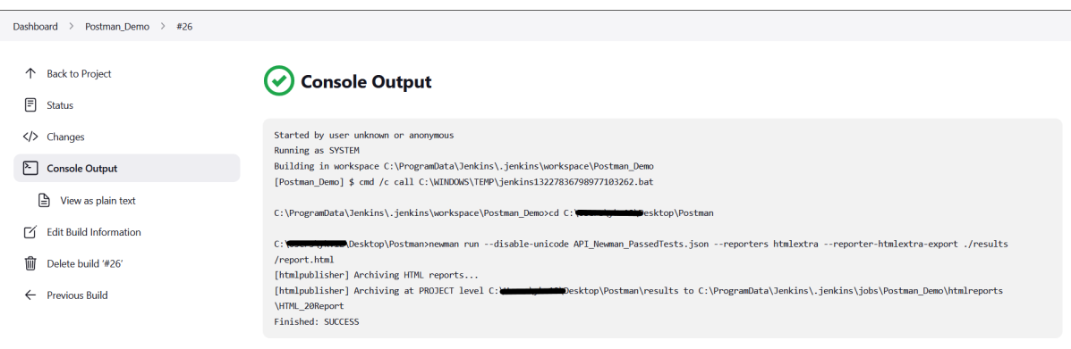

#### ***Step 9: View the HTML Report***

Once the execution is completed, click on go “***Back to Project***“, and we could see a link to view the “***HTML Report***“.

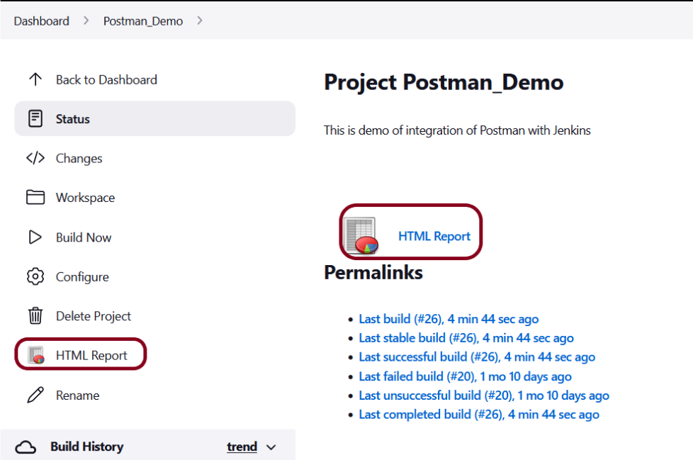

Advertisements

REPORT THIS AD

Below is the ***HTML Report***generated in Jenkins.

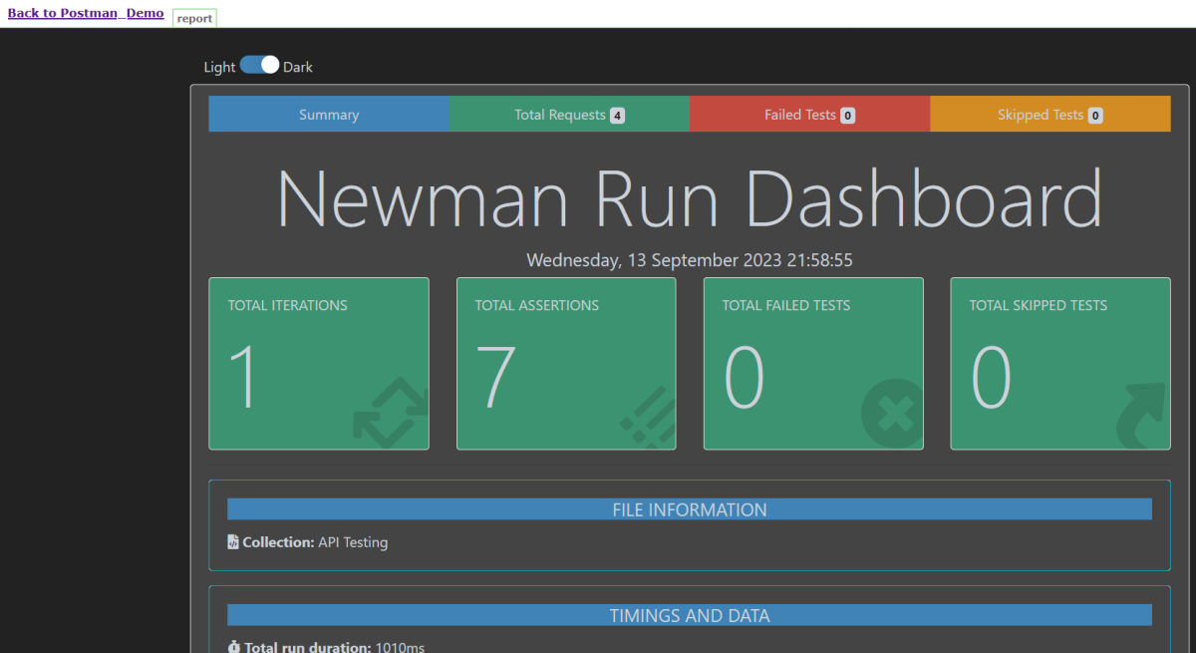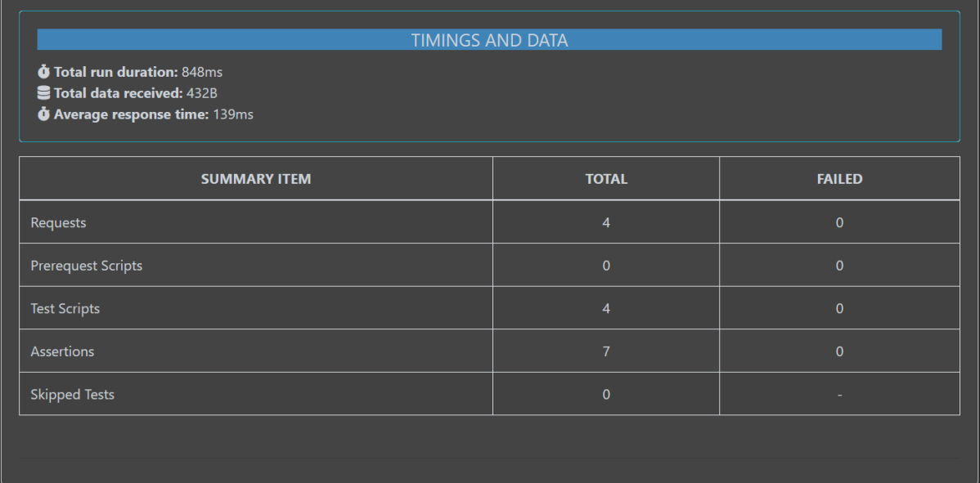

In the case, we see that HTML Report does not look very pretty. The reason is that CSS is stripped out because of the Content Security Policy in Jenkins.

Go to ***Manage Jenkins -> Manage Nodes and Clouds.*** Click on the ***Script Console*** option. Type in the following command and Press Run. If you see the output as ‘***Result***:’ then the protection is disabled. Re-Run your build and you can see that the new HTML files archived will have the CSS enabled.

|  |  |
| --- | --- |
| 1  2 | System.setProperty("hudson.model.DirectoryBrowserSupport.CSP","") |

Rerun the build again. Now you will see a beautiful report.

Congratulations on making it through this tutorial and hope you found it useful! Happy Learning!! Cheers!!